Abstract
Destruction caused by tsunami on coastal communities is primarily a function of magnitude of the source event and ocean depth at the source. Additionally the nature of the seafloor such as ridges and submarine canyons, as well as the depth of the near shore ocean floor, play a part in the speed of propagation of the wave. Finally, the built environment of the community is of utmost importance to the mitigation of the tsunami hazard.
In this paper, the La Jolla Shores community of San Diego CA was used to assess a tsunami model parameters and functionality with regard to a specific beach. The simplistic model developed for this paper could apply to other beach communities to examine mitigation techniques.

Introduction
Tsunami, a Japanese word that means harbor wave, are ocean waveforms of immense magnitude. Sources for these waves are earthquakes, earthquake induced landslides, volcanic eruptions and asteroid ocean impacts. Of these, earthquakes and earthquake-induced landslides will be discussed in this paper.
Waves that the reader may be accustomed to are wind produced ocean surface waves. Their heights are measured from crest to trough. In storms, these waves can obtain heights of over 50 feet, with half their height above the sea’s steady state. Their length can be 200 feet or slightly longer. In contrast, tsunami waves usually never gain more than a meter of height above the steady state of the sea. Their wavelength is measured in miles, some over hundreds of miles in length. Additionally, in open oceans, tsunami may travel at over 600 miles per hour (Ross, 1995). It is the speed and length that produces such devastating consequences on shorelines.
The equation for figuring the propagation speeds of a tsunami is the shallow wave equation. This is used because no matter how deep the oceans depth; the tsunami’s waveform never is detached from the ocean bottom. The equation c = (g x d)^{1/2} states that you take the square root of the gravitational acceleration (32 ft per second per second) multiplied by the depth of the water to obtain velocity (Ward, 2000).
To give an example, if you had a depth of 20000 feet, the speed of the tsunami would be 547 miles per hour. The source type of the tsunami also plays a part in the propagation speed. Waves that are produced by thrust faulting move rapidly away from the source. Waves produced by slowly evolving landslides, are slowed by the dragging effect of the negative portion of the double pulse of the wave. In fact, the propagation of this negative portion will in time overtake the positive portion and the wave will dissolve (Ward, 2000). That is why thrust fault generated waves are termed ‘tele-sunami’ and landslide-produced waves are termed ‘local tsunami’.

Risk of tsunami
Hazard assessment, risk and mitigation of tsunami are determined by the magnitude of a wave and its recidivism rate compared to what human factors are in the flooding path. In and of itself, the tsunami is not a hazard until you factor in the human element. Legal directives could remove most of the potential for risk by legislating non-building zones adjacent to shores. Of course, humans are at extreme risk from tsunami because over the last 100 years, man has highly populated the coastal zone.
Evaluating the sources and observing fossil records of past events enhance understanding and making judgments of the risk. Like earthquakes, tsunami have exceptionally long temporal scales. Yet, unlike them, tsunami records are hard to find. Fossils of tsunami events are usually dissipated within a few hundred years on most small to moderate events. Large tsunami that displace boulders kilometers inland are usually observable in the fossil record, but these events span thousands of years between episodes (Tsunami, 1999). Observing the potential sources of tsunami especially local tsunami may be the best way to ascertain risk. To use our study area for example, scientist once thought San Diego was safe from tsunami. With only a few hundred years of historic observations and the lack of knowledge about off shore faulting, we now have found that assessment was incorrect. Recently, in the spring of 2000, Mark Legg, a professor of geologist at SDSU, dove the submersible Alvin on the San Clemente fault and observed evidence of resent activity. His assessment of the faulting off shore of San Diego is one of high activity. Overnight, our risk of tsunami has now been increased drastically by changes in source evaluation. The current reassessment of three offshore faults will be used in this paper. These are the San Clemente fault, Thirty Mile Bank fault and the Rose Canyon Fault. By using these three faults, which are of varying distance form La Jolla Shores, the models performance can be evaluated.

San Clemente Island
In the figure below, you will notice the scarp on the eastern side of the island. Note too, the depth just offshore is 1000 meters (3280ft).
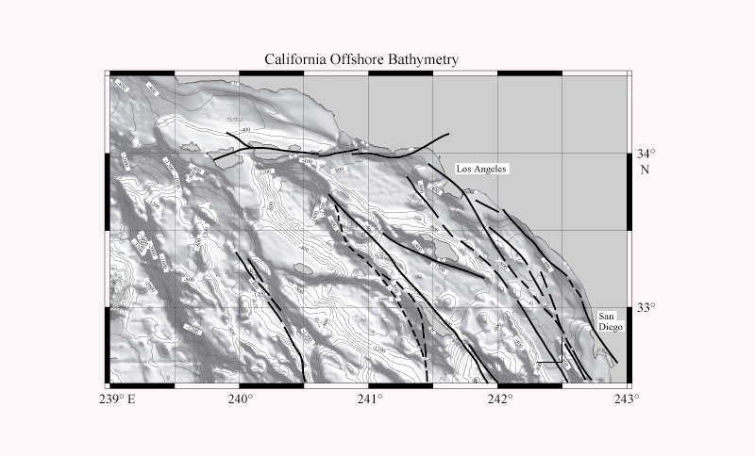
Map courtesy of Mark Ridgeway

This fault is easily long enough to produce a higher than 7-magnitude earthquake and the vertical nature of the Island and underwater terrain could easily produce a landslide.
30 Miles Offshore
The Thirty Mile Bank Fault lies kilometers from La Jolla Shores. Just recently this fault was reclassified a Thrust Fault, a very dangerous scenario because these fault types produce tsunami.
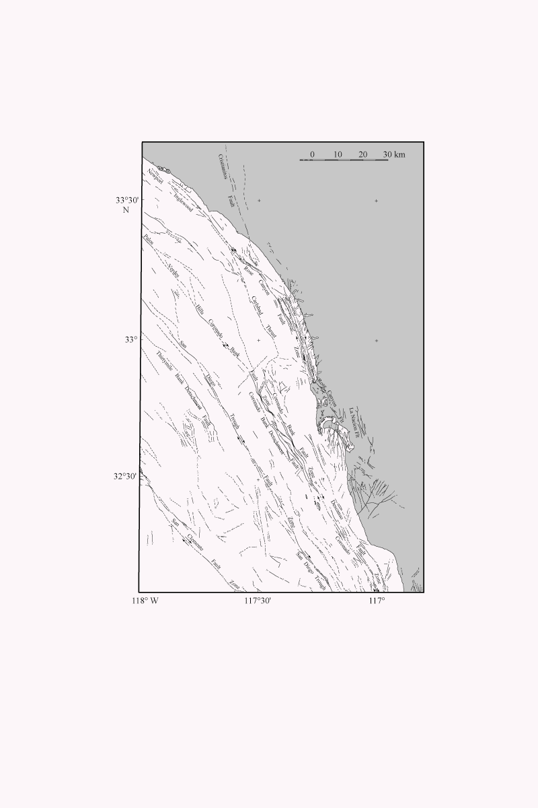
Map courtesy of Mark Legg

Rose Canyon
As you can see in the above images provided, The Shores and the Rose canyon fault are in close proximity. Combined with the extremely deep submarine canyons, the potential for a landslide is high.

Landslides
Until quite recently, landslides were not thought of as tsunami generators. Then in quick succession, earthquakes in Java and Papua New Guinea had tsunami that were the product of underwater landslides. These slides were by-products of strike-slip faulting that in and of itself would not produce a tsunami (Synolakis, 1995). It is this new revelation about strike-slip faulting that has changed the risk factor of the west coast of the US. All along the west coast, there are extreme vertical slopes and sand deposited underwater deltas. Added to this fact, many faults lay directly beneath these unstable areas.
As mentioned earlier, landslides produce tsunami of a category called ‘local tsunami’. These waves are produced slowly as the slide progresses. It is not uncommon for slides to take over 15 minutes to stabilize. These slides cover great run outs or lengths as the surface boundary layer is lubricated by the water medium. The slides will propagate far out into the alluvial plane of the sea floor. The important parameters for local tsunami generation are slide width, volume, thickness and water depth, given the fact that once started the slide will easily continue (Ward, 2000).
The depth is a direct function tsunami speed and an indirect influence on shoaling wave height. If a slide occurs in relatively shallow water, the speed of the slide may match the tsunami wave speed. This produces an amplifying effect whereas the wave ‘builds vertically’ as the positive pulse is held from initially propagating horizontally by the negative pulse. An example of this was Papua New Guinea tsunami, which was formed just offshore by landslide (Ward, 2000). The first wave crashed over houses 30 feet tall. From eyewitness accounts the wave was also breaking, most tsunami instead act as a quiet fast flood or tidal bore (Kaistrenko, 1985).
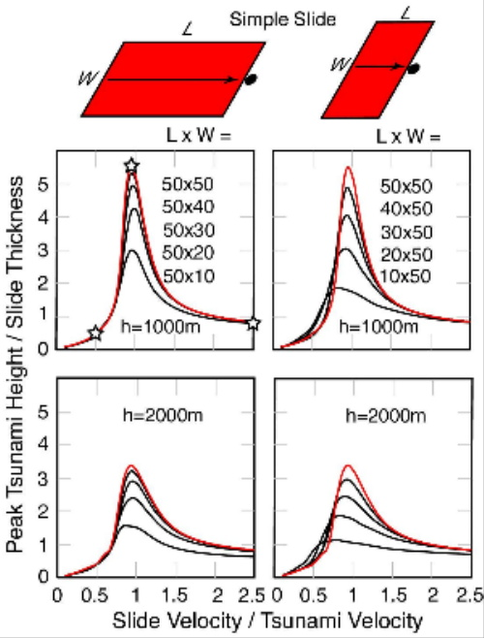
The width of the slide is important in that the ocean acts as a buffer to slide events less than three times the water depth. Of course multiple slides along a path perpendicular to the run out direction will act as a single slide, as long as they are in close proximity (Ward, 2000). As for slide width greater than this minimum, the wider the slide, the larger the area of devastation and the greater the distance the tsunami will cover at maximum magnitude.

Chart courtesy of Steven Ward
Volume is a direct indicator of wave height at source. As Dr. Ward points out; “If everything else is fixed, if you double the slide volume, you double the tsunami height”. Yet, because of how slides act in a water environment with all parameters tied to one another, Dr. Ward feels that a simple rule that can be applied is that the tsunami height at source is equal to one half the thickness. So for an average slide of one meter in thickness, you would have a one and a half foot wave. Water depth is crucial to the speed of propagation. And aside from the amplifying effect of matching speeds, the deeper the water the more force the wave will produce. This is why some of the pacific Islands with steep and deep near shores are hit with extreme force.

Seismic Source Events
With instantaneous thrusting of fault blocks moving over one another, there is never a chance for the tsunami’s velocity to equal the earthquake. For disaster preparedness of transpacific tele-tsunami, this is fortunate because though the tsunami might travel at the speed of an airliner, the seismic recorders pick up the earthquake’s waves almost instantaneous, leaving ample time for evacuation warning. Still, for those persons in close proximity to the quake, the best rule to follow comes from pamphlets provided by the San Diego County Office of Disaster Preparedness. If you are at the shore and feel a substantial earthquake that last for a substantial time (20 sec.) move immediately to high ground. Do not wait for warnings (US Gov.).

Shoaling
Sometimes used within the concept of ‘run-up height’, shoaling is a direct function of the source depth of the tsunami (Ward, 2000). Shoaling provides an enhancement function to the height of the tsunami at close proximity to the beach, usually measured at a depth of a few meters. Secondarily, other factors can play a role in diminishing or amplifying this shoaling function. Of note is the effect of submarine canyons on tsunami. These canyons can focus the wave and allow for faster wave speed (speed is functional on depth). An example of this will be given later in the text.

Modeling
Designing a model for mitigation of tsunami devastation in La Jolla Shores requires that we assess aspects of risk and hazard from local tsunami. It is believed that our risk to tele-tsunami is quite low due to our offshore islands. For local-tsunami, risk to persons and buildings are of primary importance. Since the Shores is an already built environment, limiting structures to the area of potential inundation is not an option. Therefore our attention will be focused on risk to person. This will fall in evacuation of persons either horizontally or vertically. A study of structural integrity to tsunami points out, that most structures built in developed countries are able to withstand loads produced by tsunami of two meters in height. Still, this does not take into account foundation failures or liquefaction that may occur. Note that wherever the water table can reach the surface, liquefaction during seismic activity can occur. The image below shows the La Jolla Shores area when it was still a marsh. If after tsunami flooding another aftershock should occur the whole area could liquefy.
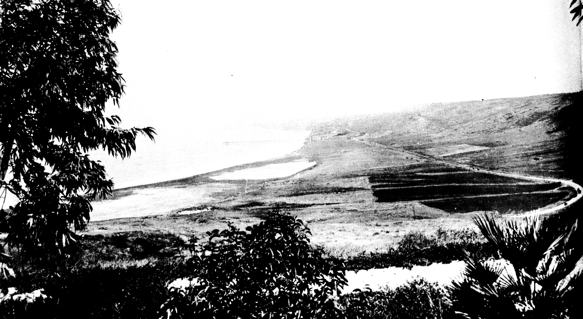
1930 image provided by the F. Sheppard collection

The State of California has evacuation maps that were produced by Dr. Synalacas at University of Southern California. These maps give an evacuation elevation of forty-two feet. These are generalized maps for the whole state, but using a recognized landmark in the La Jolla Shores area that approximates that height should fulfill a horizontal evacuation line to reach. By using Torrey Pines road that runs north from Ardath road, this would be the likely distance to reach for safety. From the coast one can walk this distance in five minutes. Still, many persons may not leave in a timely fashion from the beach, or the event may preclude even this minimal evacuation time. Disaster agencies state as a last resort the evacuation to the forth floor of a building. As long as the building holds, this puts the person above a theoretical flood height. For the Shores area, it is the author’s believe that a means of mitigating the hazard to beach goers, is the construction of observation platforms that would allow evacuation in the case of tsunami. Dr. Legg of SDSU presented the idea in an informal discussion. Of course these platforms would need to serve multiple purposes, as the temporally long recidivism rate of tsunami would preclude such an expense for just such an event. These platforms could serve as observation areas for spectators of beach activities such as surfing events or concerts. Lifeguard towers could be incorporated into the structures. At present many towers on the San Diego City Beaches are in disrepair. As a source for funding for building such structures, lower levels could be rented out to retail businesses. There are three criteria that are of importance for these structures. First, is the ability to allow wave passage without vertical enhancement to the wave (walls can not be perpendicular to the wave). Second, foundations need to withstand undermining. The model presented in this paper gives an example of determining the third criteria, which is a structural height minimum.
For underwater slides, a simplified model of determining the shoaling height of the tsunami in two meters of water is given. This model will be explored in an example for the San Clemente fault area and the Rose Canyon fault. Additionally, the model will be adapted to a thrust fault event and an example will be given for the Thirty Mile Bank fault. Note, these models are derived from complex mathematical formulas researched and designed by Dr. Ward.

Local Tsunami Model

Evacuation Time
The evacuation time is equal to the earthquake event plus time till slide commencement plus slide propagation time plus tsunami propagation time.
The earthquake event is the duration of the earthquake. Because it would be hard to tell the exact moment the slide or block could release and quakes usually last under a minute, the example starts the evacuation time directly after shaking. Slide commencement could occur at any time after the quake. The example uses an immediate commencement. As mentioned earlier, the slide can propagate for many minutes. The example uses 5 minutes as the time of propagation.
Tsunami propagation time is the time it takes the tsunami to travel the distance from source to target. This is a function of water depth. As shoaling occurs as you approach the shore, a continuous diminishing function occurs. Average depth has to be estimated, as the shoaling will change the speeds of propagation.

Tsunami Source Height
The height at the source for a slide-generated tsunami is one half the average thickness of the slide.

Shoaling Height
The shoaling height is equal to the source height divided by the shore height carried to the .25 power (Ward, 2000).

Minimum Width
The minimum width is three times the depth of the ocean at the source.

Example

San Clemente fault

Given that there is an earthquake of magnitude 7 on the San Clemente fault, the minimum time of evacuation is found by taking the distance from source to target and dividing it by 2 times 2400 ft. (depth at source). This produces speed range cells of approximately one mile in length. If the event takes place 50 miles away, all cells in the first 30 miles will have an average depth of 3200 ft. The next 15 miles have an average depth of 2400 ft. Within the submarine canyon off shore of La Jolla the next 4 miles have an average depth of 1700, with the last mile 600 feet. Outside the canyon, the 4-mile segment averages 600 feet and the last mile averages 30 feet. Note these are crude measurements, as accurate bathymetry depths were not obtained. The functional relationship for propagation time within the canyon is as follows:
30/{[(32 x 3200)^{.5} x 60] / 5280} + 15/{[(32 x 2400)^{.5} x 60] / 5280} + 4/{[(32 x 1700)^{.5} x 60] / 5280} + 1/{[(32 x 600)^{.5} x 60] / 5280} + 5 = ~ 20.25 minutes
Outside the canyon the speed of propagation is:
30/{[(32 x 3200)^{.5} x 60] / 5280} + 15/{[(32 x 2400)^{.5} x 60] / 5280} + 4/{[(32 x 600)^{.5} x 60] / 5280} + 1/{[(32 x 30)^{.5} x 60] / 5280} + 5 = ~23.5 minutes
If the slide is one meter thick, then a conservative estimate of the height of the tsunami at the source is going to be ~1.5 feet. In our example the height of the wave just 100 yards offshore would be as follows for the submarine canyon:
(3200 /50)^{.25} = 20 feet x 1.5 or 30 feet (This is the shoaling equation to 50 ft.)
Outside of the canyon, 866 yards offshore the height would be the same.
Clearly, from this example, the wave would strike the canyon head area over three minutes earlier and the maximum height for structures to allow the wave to clear underneath them would need to be at least 30 feet high. Waves outside of the submarine canyon would loose height and energy much more rapidly as they reach shore. Note that outside the canyon, wave speed would be slowed to approximately a little over 20 miles per hour as compared to almost 100 mph at the canyon head.

Rose Canyon fault
The example of Rose Canyon is given as a worse case scenario. Lying just offshore of La Jolla Shores, The wave could move almost instantaneously with the slide. Drawing attention to the image provided, note that the Scripps Canyon and the La Jolla Canyon cut deep ravines almost immediately from the shoreline. Allowing for the fact that the depth at intersection is approximately 1500 ft, the area transecting the canyons at the 100-foot level has more than enough width to produce a tsunami. And don’t let the direction mislead. As Dr. Ward points out, sand type slides can “beam the tsunami upslope towards shore”(Ward, 2000). Also, historic evidence indicates that advancing of the submarine canyons towards the shoreline has drastically increased, possibly due to mans influence on the shoreline. Whereas the canyons normally moved about an inch per year, between 1950 and 1964 the advance increase to over two foot per year (Kuhn, 1984).
Using the shoaling equation for four feet:
(1500 / 4)^{.25} x 1.5 feet = 6 feet.
The speed could be: 1/{[(32 x 1500)^{.5} x 60]/5280}= 40 seconds for propagation + 30 seconds for slide time or a little under two minutes before an almost two meter wave traveling at just under 100 mph pushes ashore.

Seismic Generated Tsunami
The model for a tsunami produced by seismic thrusting of faults changes slightly in both evacuation time and source height evaluation. Because there is no slide propagation the tsunami moves immediately from the source event time. Additionally the magnitude of the thrust fault earthquake provides a functional relationship as to the tsunami height at source. A chart constructed by Dr. Ward is provided below.

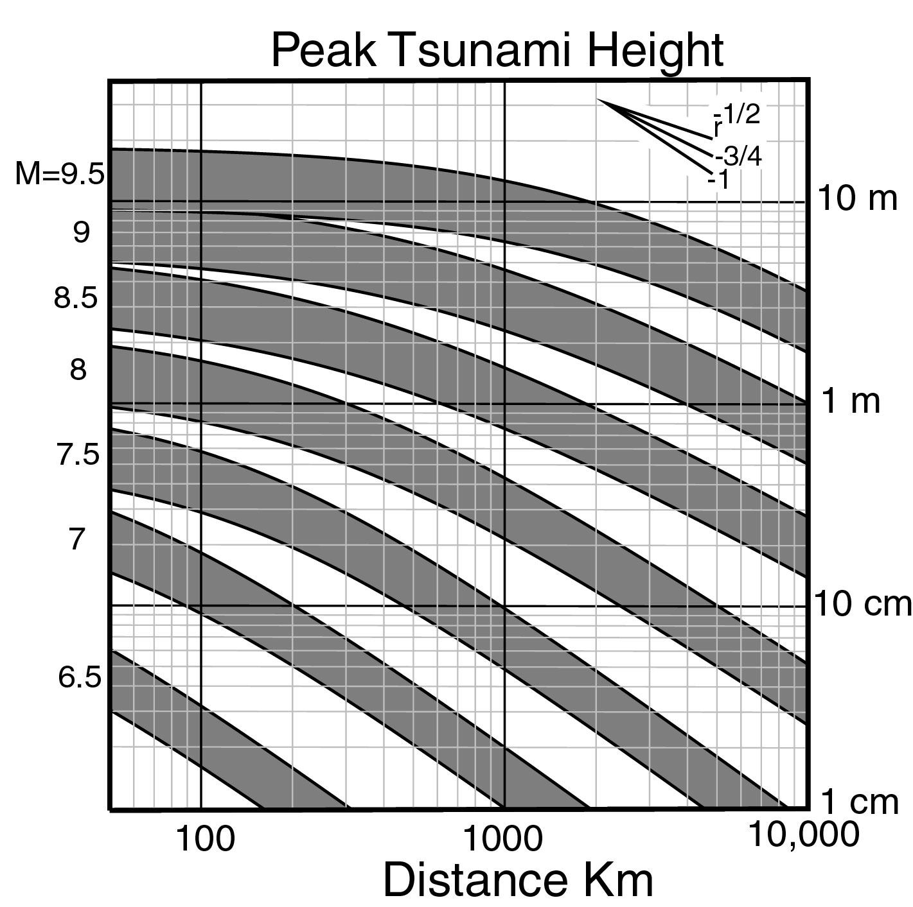

As Dr Ward points out, an earthquake with magnitude 7.5 would have a fault length of 89 Km (~58miles) and the resulting tsunami height range would be from 40 to 80 cm for distances of 30 miles (30 Mile Bank fault). This does not include shoaling. If shoaling is to 2 meters of depth, then (1000meters/2meters)^{.25} x ~60 cm = 2.8 meters. The time factor without ranging the bathymetry would be 30/{[(32 x 3280)^{.5} x 60]/5280}= ~8 minutes. With range grading for slope, the arrival time would be ~12 minutes. So given an event of 7.5 magnitude on the offshore thrust fault, a 9 foot wave traveling at approximately 100mph would hit the Shores in under 10 minutes.
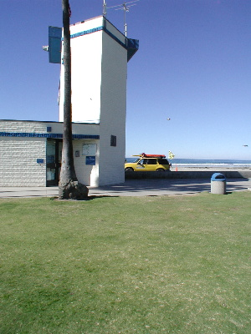
The image below is given for reference of heights

Note the upper blue band on the Lifeguard tower is approximately 30 feet high.

Conclusion
This paper shows how simple modeling of earthquake faulting and associated source events can produce useful tsunami information at a shoreline. More complex mathematical modeling was simplified to produce wave height at shoreline and a time till impact models that can be easily understood. Liberties were taken with regard to simplifying the speed propagation formula. By range grading the ‘speed cells’ with a hypothetical multiplier of source water depth, canyon type bathymetry influence can be compared to generalized slopes. Using generalized bathymetry depths, the accuracy of true time is suspect. More evaluation of range grading and obtaining precise depth data would surely increase accuracy. Additionally, more information is needed on the make-up of the seafloor at the event locations. Dr. Legg has shown the importance of this aspect with dives in the spring of 2000. Finally, it is hoped that this paper lends itself to further enhancing the knowledge of disaster planners for the San Diego region, by complimenting the inundation mapping performed by USC.

Bibliography

Kaistrenko, V. M., 1985. “Analytical Theory for Tsunami Run Up on a Smooth Slope” in a paper presented at the Institute of Applied Physics, Academy of Sciences of the USSR, Gorky, Russia.
Kuhn Gerald G., 1984. Sea Cliffs, Beaches and Coastal Valleys of San Diego County California. University of California Press at Berkley.
Legg, M.R. and Kennedy, M. P., 1979. Faulting Offshore San Diego and Northern Baja California. In Earthquakes and other perils, San Diego Region, ed. P. L. Abbot and W. J. Elliott, 29-46. Guidebook prepared for Geological Soc. of America Field Trip, by the San Diego Assn. of Geologists, Nov. 1979.
Legg, M., 2000. collocrium on Offshore Faulting, Nov. 2000. Hosted by Dr. Eric Frost, San Diego State University Dept. of Geology.
Ross, D., 1995. Introduction to Oceanography. Harper Collins College Publishers.
Synolakis, C., 1995. “Damage, Conditions of East Java Tsunami of 1994 Analyzed” in the American Geophysical Union, Vol.76, No. 26, June 1995 pp. 257, 261-262.
Tsunami. “Geological Records of Tsunami Events” in publication by the 2000 Natural Environment Research Council, Coventry University and University College London. UK.
US Government, publication from a joint program in association with the Governor’s Office of Emergency Services, Coastal Region Earthquake Program. Oakland, CA.
Ward, S., 2000. “Tsunamis” in the Encyclopedia of Physical Science and Technology, ed. R. A. Meyers. Academic Press, in press.
Ward, S., 2000. ‘Discussions on simplifying tsunami model responses to variables’. ward@uplift.ucsc.edu. Institute of Tectonics, University of California at Santa Cruz.

