Counting Recreational Users at San Diego Beaches
During Labor Day 2000 Weekend from
Helicopter-Based Aerial Photography

Project for the State of California Lifeguard Service in the
Southern District of the State of California Parks and Recreation.
Supported by Parks and Recreation Superintendent Edward Navarro

Project performed by Krauss Helicopters, Inc. and Imagis

Project Participants
John Ryan <Project Developer>
Lloyd Coulter <Technical Leader>
Ken Krauss < Pilot>
Laurie Cooper <Co-pilot/Technical Assistant>
Dale Cooper <Technical Assistant >

Performed in association with the Department of Geography
at San Diego State University

Abstract

This paper describes a systematic procedure for collecting accurate counts of beach goers with vertical aerial photographs and ground-based digital images taken from lifeguard towers using a panoramic camera. Photography was captured at the Silver Strand, Torrey Pines, San Elijo, and Carlsbad state beaches during the Labor Day 2000 weekend. While the aerial photographs provided complete coverage of the beaches, the ground-based panoramic imagery documented the field of view from selected lifeguard towers and provided a means of validating the counts derived from the aerial photographs. In addition to manual interpretation and counting from the aerial photographs, this study tested procedures for semi-automated counting using digital image processing techniques.
Beachgoer counts derived from the aerial photography corresponded well with ground-based counts for the same beach segments. Error associated with interpretation of 5x7 prints was found to be approximately 20%. This error can be significantly reduced through use of an alternate counting method. Semi-automated classification of the percent cover of human attributes provided a moderate relationship with the actual number of beachgoers present. However, the relationship was found to vary by beach segment, as individual beaches have different proportions of human paraphernalia such as umbrellas.

Introduction

The San Diego County State Lifeguard Service, like many public lifeguard agencies, needs information on the number of beachgoers during moderate to peak seasonal use. Three primary benefits are obtained by having these counts. First, by tabulating the number of users over a given length of time, the lifeguard service can develop a budget for allocating resources to meet the demand placed upon them by the public’s beach use. Secondly, when soliciting funding from the State of California, accurate numbers of beach users helps support decisions pertaining to fund allocation. Finally, consistent and accurate data of seasonal and annual beach use will allow the Lifeguard Service to predict yearly increases in demand.
At present the State Lifeguard Service can provide accurate data on use in state parks that have a single entry point, as users are counted and charged a fee upon entrance. The Silver Strand is the only beach in San Diego County, which can be categorized as having a single entry point. All other beaches that the State Lifeguards govern within San Diego County have multiple entry points and an accurate count based on ingress and egress of beachgoers is not a realistic option. For these beaches, estimates of the total number of beachgoers must me extrapolated from sample counts of people within zones around lifeguard towers.

Objectives

The primary objective of this project was to capture aerial photography and provide accurate counts of persons recreating at San Diego state beaches at that moment in time. A second objective was to compare populations counted from the oblique viewing angle of lifeguard towers to those obtained from the aerial photography. We could then determine if the two methods are comparable and provide an indication of the relative reliability of each. It was hypothesized that within a given area, the two view positions would produce the same total counts.

Methodology

Vertical Aerial Imaging
Aerial photographs were captured on Labor Day 2000 weekend for selected beaches from a helicopter platform at 1100 feet above ground level (AGL). Complete coverage was obtained for the State beaches at Border Field, Silver Strand, San Elijo and Carlsbad. The city beach at La Jolla Shores was also included, as it enabled assessment of counting methods and accuracy at densely populated beaches. The helicopter flight line was positioned so that all of the beach area was visible as well as a substantial portion of the near shore ocean area. A 35 mm Nikon F3 camera was utilized and each photograph imaged an area on the ground approximately 225 meters by 150 meters (along shore and across shore, respectively). Often, parking lots adjacent to the beach were included in the photographs. The image below illustrates a photograph from La Jolla Shores (Figure 1).

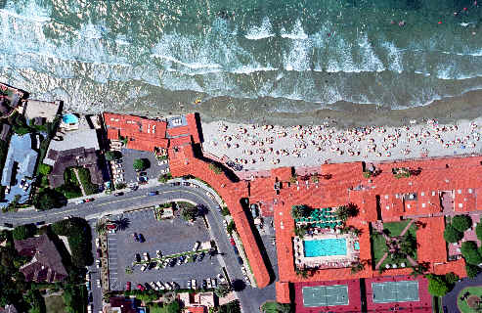

Figure 1. Southern most beach at La Jolla Shores

Counts from Aerial Photography
Counts were obtained for each photograph of the imaged beaches. The number of beachgoers was interpreted from 5x7 prints using a 7x magnification loop. Some degree of double counting and omission of subjects was unavoidable. Counting rules were established to provide consistency between interpreters. All persons visible in the water and on the sand were counted. Umbrellas masked people from view, but were assessed as one person per small umbrella and two per large umbrella. Persons within parking areas and sidewalks/boardwalks were counted, as they were considered participants of beach recreation. In addition, moving cars within parking lots were known to have people inside and were assessed as containing two beach participants.
Identification of beachgoers was subjective in some instances as it was hard to discern people from other items within the scene (coolers, towels, upright surf boards, etc.). An assessment of counting consistency between interpreters was performed to provide an indication of the potential variability within the final counts obtained from each photograph collected. Fifteen photographs containing a variety of beaches, scene conditions, and a wide range of beachgoers were selected. Five interpreters counted the number of persons within each of these scenes and the resulting counts were compared. The fifteen photographs included scenes from the Silver Strand, San Elijo, Carlsbad, and La Jolla beaches. La Jolla was chosen because of its high traffic use on the day of the imaging. The Labor Day weekend had a light turnout due to cool weather and it was felt that a high use area was needed to assess the procedure on a crowded beach.
To obtain the highest possible beach count accuracy against which the counts from the five interpreters could be compared, eleven of the fifteen photographs were scanned from the film negatives at very high resolution (2000 by 3000 pixels), and computer assisted counting was performed. The digital images were viewed using ImagineTM, an image processing software package by ERDAS, Inc. ImagineTM enables an annotation layer to be added over the image. By placing counting marks over each visible person, errors in double counting and omission were avoided. Each person and umbrella was counted. In the image below, different annotation symbols were overlaid for counting purposes. Stars represented people and circles represented umbrellas (Figure 2).
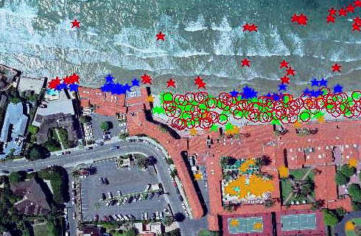

Figure 2. Computer assisted counting of beach-goers and umbrellas at La Jolla Shores.

Ground-Based Oblique Imaging
To obtain numeric counts of beachgoers within the field of view of the lifeguard towers, panoramic images were taken from the towers. The panoramic images were then processed into a virtual reality image of what would be seen from a lifeguard tower. Virtual reality scenes were built for the Silver Strand, Torrey Pines, San Elijo, and Carlsbad state beaches and the La Jolla Shores city beach. The panoramic images allowed counting of persons within the view field in a computer laboratory. In addition, the panoramic images enabled various counting techniques to be tested in a non-changing setting. The panoramic images were acquired with an Olympus 3030 digital camera on a Kaidan rotating mount. Approximately ten images were used to stitch together a 360-degree panoramic image for each location. A resolution setting of SQ1 was used, which corresponds to an individual image with a digital resolution of 1280x960 pixels. The image below was a computer screen capture of the actual virtual reality scene (Figure 3).
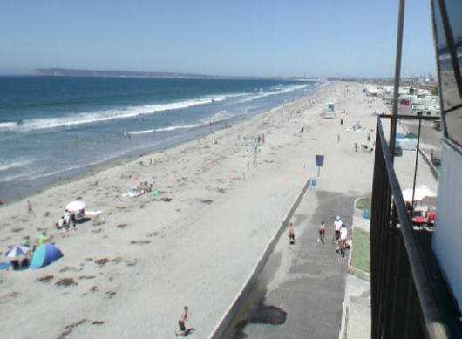

Figure 3. Portion of the panoramic image from the Silver Strand Lifeguard Tower.

Persons within the virtual reality scene were counted if they were between the camera location at the tower and boundary objects clearly recognizable in the aerial images. In the image above, the northern lifeguard hut was chosen. Counting beachgoers within the same segment of beach using the ground-based oblique photography and the aerial photography allowed comparison and cross-validation of each technique. Because the virtual reality view could be panned just like a lifeguard would sweep his view across an area, accuracy assessment of the real time view of a lifeguard could be performed.
Images were taken at various lifeguard stands and towers within the areas patrolled by State Lifeguards and at the La Jolla Shores. These images were then converted into panoramic image strips by a process called stitching. The image strips were then converted into a virtual reality scene by warping the image strip and generating a Quicktime MovieTM (a product of Apple, Inc.). VR ToolboxTM was used to build the virtual reality scenes.
Capture of the virtual reality scene from the lifeguard tower enabled analysis of counting procedures to be carried out in a laboratory setting. The advantage of virtual reality scene over traditional photographic prints is that it allows continuous and uninterrupted panning of the field of view. In addition, the virtual reality scene can be used in presentations to give a "first person frame of reference" and enhanced insight into the qualities of the site.

Analysis of Automated Counting from Digital Imagery

Manual interpretation and counting of persons from photographs and digital images is time intensive. This project investigated the use of automated processing of digital images for estimating the number of beachgoers within individual scenes. The technique involved classifying cover materials within the scenes and labeling the resulting cover classes as sand or beachgoer related material. A relationship between the percent of the scene that was associated with beachgoers (towels, coolers, umbrellas, etc.) and the number of persons was sought. If a relationship were found to exist between the percentage of sand covered by beachgoer related items and the number of people, then future photography could be acquired at lower resolutions covering larger areas and manual interpretation would not be required. Both of these features could lower costs associated with beachgoer counting from aerial photography.
Images were spectrally clustered using an unsupervised classification algorithm. A 50-cluster class product was generated which enabled separation of many spectral components in the image (such as clothing, towels and sand). The non-sand (human attribute) pixels were summed and then divided by the total number of pixels to obtain the percent of the scene that was associated with people and their paraphernalia. These percentages were compared to the total number of persons present (as interpreted from the scanned photographs) on a photograph by photograph basis. It was hypothesized that percent coverage would correlate to the number of beach-goers. Two methods for labeling spectral classes were explored because some spectral signatures of sand were the same as the spectral signatures of human attributes (e.g., umbrella shadows and dark sand). The two approaches are apparent in the Figure 4 and Figure 5 below. Sand pixels have been changed to a uniform color with human attribute pixels remaining in a gray scale. Note, due to correlation between sand and objects, areas of human attributes have diminished. For analysis we chose the classifier that included the shadowed areas with sand as this included darker patches of sand as well.

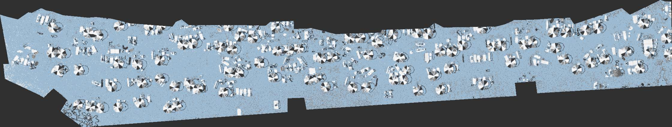

Figure 4. Unsupervised classification with shade labeled as sand.

Figure 5. Unsupervised classification with shade labeled as human attribute.

Results

Aerial Photography Counts and Interpreter Variability.
Beachgoer populations counted from the aerial photographs are given in Table 1. The counts are provided on a per-photograph basis and totaled for each beach segment. The number of beachgoers counted on all beaches combined was 10246.
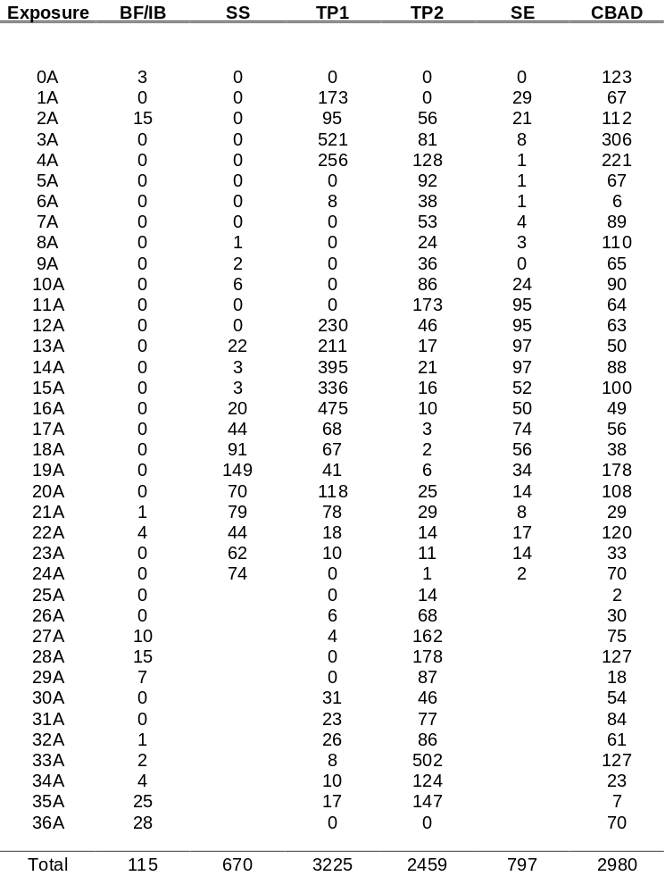

Table 1. Beachgoer counts from Labor Day 2000 Weekend. Beaches are: Border Field/Imperial Beach (BF/IB); Silver Strand (SS); Torrey Pines (TP1 and TP2 - two film roles required); San Eligo (SE); and Carlsbad (CBAD). Silver Strand and San Elijo beaches were imaged with 24 exposure film roles.

The variability of individual interpreter counts compared to a reference count is given in Figure 6. The individual interpreter counts generally track the reference count, and demonstrate over and underestimation. The mean absolute error (MAE) between the interpreter counts and the reference count was computed and plotted against total number of persons within each photograph (Figure 7). The resulting graph illustrates that interpreter variability increases as a function of the number of subjects within the scene. Further, Figure 7 indicates that the average variability (or likely counting error) is on the order of 20% of the total number of subjects within a given scene.
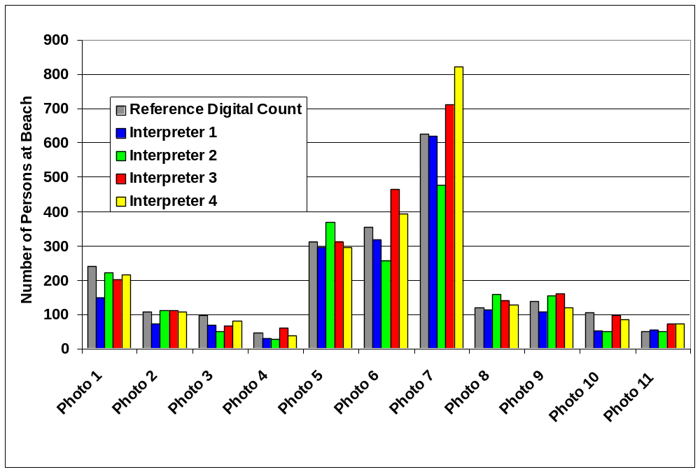
Figure 6. Count variability between interpreter and reference digital count of eleven photographs
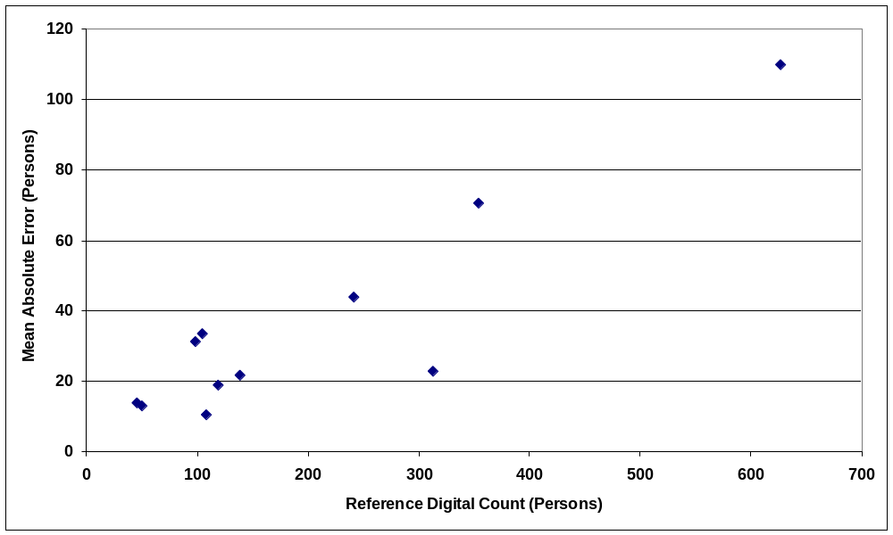

Figure 7. Mean absolute error between four interpreters and reference digital count of eleven photographs

Ground-Based Oblique Counts verses Aerial Counts.
Three locations were chosen from the La Jolla Shores and Silver Strand beaches to ascertain whether counts from the aerial photography would compare to counts from a lifeguard's oblique view. Two panoramic views of the Silver Strand were obtained. One was from the tower and the other was from a lower hut (as illustrated in Figure 8 through Figure 10).

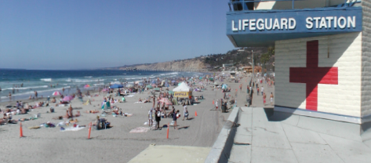
Figure 8. Ground-oblique view of La Jolla Shores.

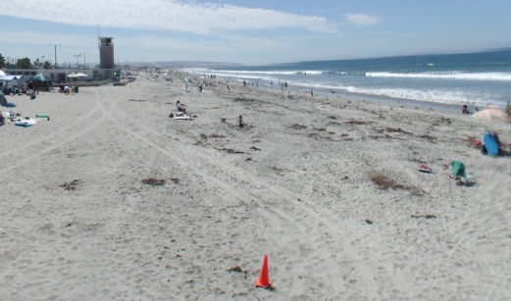
Figure 9. Ground oblique view of the Silver Strand looking south from the north hut.

Figure 10. Ground oblique view of the Silver Strand looking north to the hut.

The counts from the aerial photographs agree well with the oblique perspective counts obtained in the Virtual Reality views. The counts from ground oblique and aerial photographs, respectively were: 253/242 at La Jolla Shores; 178/195 at the Silver Strand Tower; and 82/95 at the Silver Strand Hut. Figure 11 graphically illustrates the agreement between aerial and ground-based counts and indicates that aerial photographs provide a robust means of accurately counting subjects along entire beach lengths.

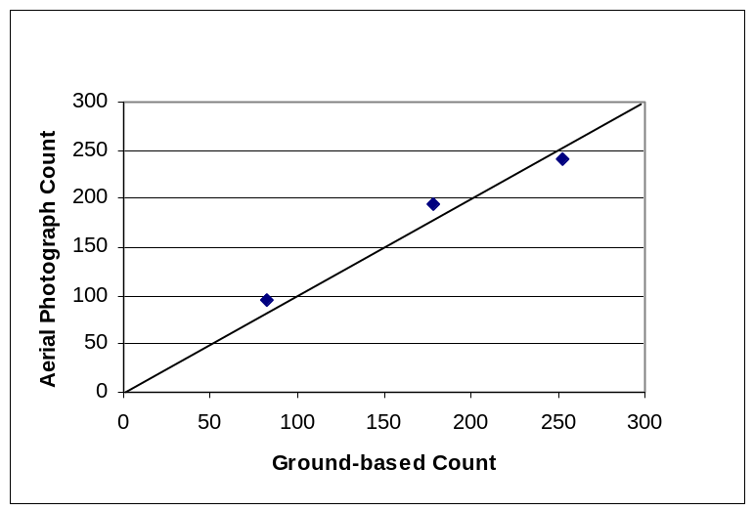

Figure 11. Comparison of aerial and ground-based counts for three beach segments. Line of perfect agreement (1:1) is illustrated on chart.

Semi-Automated Counting Analysis
Using ImagineTM software to spectrally cluster pixels for simplification was not found to be of benefit for comparing different beaches to each other. But for analyzing a particular beach to itself, the technique holds promise. The 50 cluster unsupervised classification isolated the human attributes from the sand well enough to give an accurate percentage of area output for the particular beach. The results would not be comparable to other beaches that had a different use. Many beaches are advantageous to allowing users to bring umbrellas, while others are not. If you look at the images in Figure 4 and Figure 5 you will see that to cover spectrally the darker colored sand you must also mask over human attributes. This also means that for comparing the same beach temporally, care must be taken with regard to shadowing. Figure 12 shows that area covered by non-sand does not always correlate to linear increases of beachgoers. The two outliers are from areas of the La Jolla Shores, which had high traffic. The point with the highest percent of human attributes was covered with umbrellas while the point with the highest number of users had noticeably few attributes (few umbrellas or towels present). By removing this outliers, one can see high correlation in the other beaches. Data from ‘like’ beaches should provide a cost effect means of beachgoer counts.

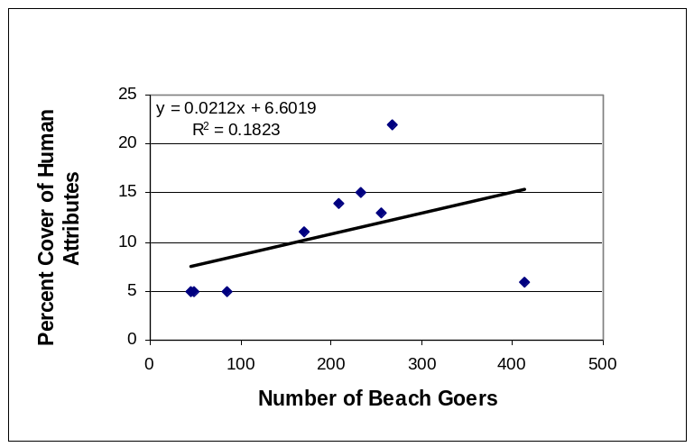
Figure 12. Relationship between percent cover of human attributes and number of beach goers at La Jolla Shores and Silver Strand beaches.

Conclusions

Interpretation of aerial photography provides the most accurate count of beach usage obtainable over large extents. The counts from the aerial photography had strong agreement with those derived from a lifeguard's tower perspective at selected beach segments. While error associated with interpretation of 5x7 prints was found to be approximately 20%; this error can be minimized by implementing an alternative counting method. A suggested approach for future counts from aerial photography would include use of slide film and generation of mounted slides. These slides could be projected onto a dry-erase board and persons to be counted could be marked and tallied. This approach would minimize errors associated with omission and double-counting. Further, the interpreter could dwell on a subject while determining whether or not the subject is a person. Counting from 5x7 prints required continuous, uninterrupted panning.
Counts derived from semi-automated digital image processing were not found to have high utility in this initial study. Scanning negatives at very high resolutions is expensive, and image processing with hundreds of frames is likely to be cumbersome. Further, relationships between percent cover of human attributes and the actual number of persons present varies by beach and beach segment. Clearly more research would need to be performed before attempting to use this technique.
The number of persons estimated to be under umbrellas should be looked into during future projects. Oblique views obtained for the panoramic images at multiple locations should provide a good indication of the average number of persons that can be considered to be under the umbrellas. For example, two chairs are clearly visible under the umbrella in the lower left corner of the image in Figure 3.
As an alternative to counting from aerial photography, it is believed that oblique viewing will work quite well for use as a sample method for estimating total daily beach use. The mild discrepancies in the oblique verse overhead counts, shown in figure 11, may be attributed to low-resolution images used in the panoramic scenes. By using higher resolution settings (larger field data storage), accuracy may be improved in the panoramic images.

Future Analysis

The correlation of total beach use to sample areas of beach goers at a ‘specific moment in time’ now can be explored. Comparisons of additional test days in the summer of 2001 will establish a functional equation for estimating beach use from observed sample areas (Lifeguard Towers). For a final functional relationship to be established, a minimum of three additional flight days would need to be performed. The Labor Day weekend of 2000 was extremely cold and the turnout was moderate. Data for high volume needs to be obtained to see if the relationship of high volume use stays linear with moderate volume. Peak volume data is pertinent to establish functionality of density increase. It may be observed that extreme volume reaches a saturation level where density of beachgoers does not increase but stabilizes (beachgoers move to lower density areas). If this were the case, then counts taken from high traffic lifeguard stands for samples would underestimate total beach use on peak use days. Low traffic areas that border high traffic areas will provide information as to whether this density diffusion occurs. In a linear function, density at both high traffic and low traffic areas would show the same proportion of increases. On a peak use day, if low traffic areas increased noticeably over high volume days while high traffic areas remained the same as high volume days, then diffusion would be shown to occur. This is not detrimental to establishing a field counting procedure; it would only entail using additional sample sites (more personnel).
To compile a daily use figure, a multiplier will need to be established to cover turnover. Lifeguards interviewed at the Silver Strand, Torrey Pines, Carlsbad and La Jolla Shores beaches felt that a 15 % morning turnover and a 25% evening turnover occurred each day. These percentages were not analyzed in this initial study, though future timed virtual reality scenes could provide a turnover rate by showing persons coming and going throughout the day. Surveys of beachgoers can also provide information about arrival and departure times from the beach area. Answers to these questions can be explored more fully during the 2001 season. Daily use figures of the total beachgoer population should be obtainable by factoring daily turnover rates with single ‘moment in time’ beach use counts.

